Switcher Studio Technical Set-up
It is strongly recommended that you practice connecting the devices ahead of time to leave time for troubleshooting. Allow at least 30 minutes for the first set-up at the rink.
Download the Switcher Studio App on all devices.
$49 US per month recommended – remember to cancel subscription for off season.

On the viewing device:
1. Connect to wifi.
2. Log In to Switcher Studio
3. Disconnect from wifi and connect to Google nest (by switching wifi network to nest – the name of the network is likely to be setup… )
4. Back to Switcher. Select Use as Switcher.
NOTE: If you use wifi to connect the devices instead of the Google nest, you will get removed when someone else tries to connect. Best to use Google Nest to connect devices then the connection is private.

On all other devices:
1. Connect to Google nest.
2. Select SHARE THIS DEVICE
3. Select SHARE THIS CAMERA (first time - choose “always allow”)
4. Back to the main viewing device…

On the viewing device while in Switcher (USE AS SWITCHER).
1. The first time you use Switcher you will need to select NONE under the Broadcasting section.
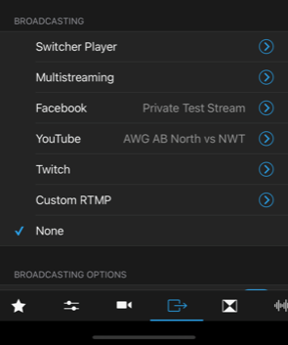

2. Select the video camera icon on bottom and connect to other devices by selecting each one.
The names of the other devices will show up under “Sources on your wi-fi network”. Select each one to connect.
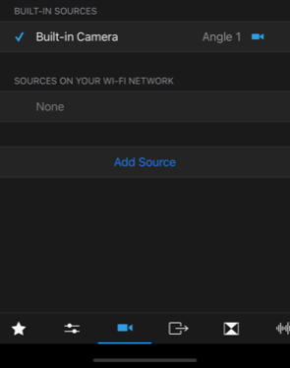

2. Configure viewing preference (3 cameras, 2 cameras…)

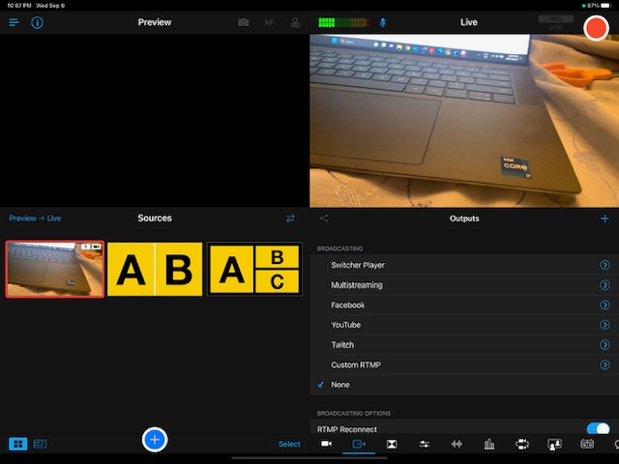

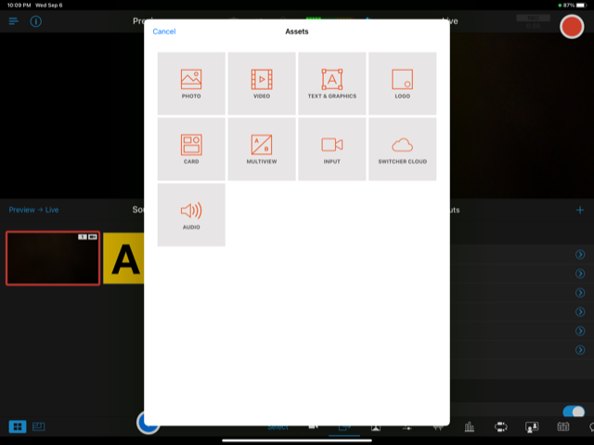

Select 3 views or 2 views.
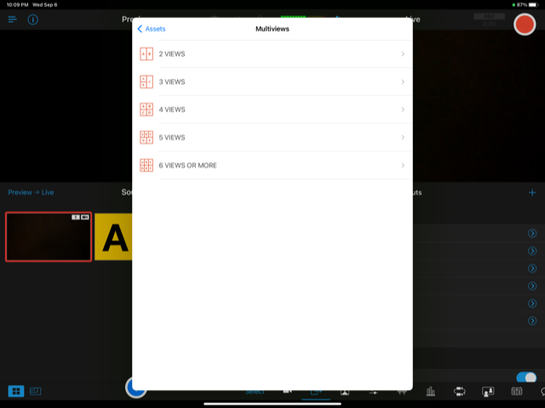
After this screen, you will be taken back to main screen.
Tap each camera view in the order you want to see it (A-B-C).

3. When you have the view as you want it, touch PREVIEW TO LIVE.

4. Start and stop recording using the red circle button on top right.

5. When you hit stop, the video will be processed and you can then hit play on the next screen to view it and toggle slow motion or back and forth by sliding the bottom bar.

If you want the clip saved to photos to download or airdrop choose - Export Recorded File.

SET-UP laser, plumb line tips:
- Place plumb line halfway between the hack and camera.
- When lining up the laser, it works best if you place the rock behind the hack with the handle lined up to where on the hack we want the laser to be (middle of the hack).
- Then where the plumb line will be, place a rock with the laser in the middle then line the plumb line up. This should make it easier to line them up. Remove the rock.
- Last, place the camera behind the laser so that the plumb line and laser are lined up on the screen.

Contact renee.sonnenberg@curling.ca or 780-518-1214 if you encounter difficulties.

