Equipment List for Technical Video Analysis

4 iDevices
- 3 phones
  - Behind the hack
  - Behind the laser (use iPhone with best camera here)
  - Side view (this one is the most optional – great to have and best views are front and back)
- iPad to view the clips (best to be a bigger screen)
2 tall tripods – one for behind laser and one for viewing with athlete on iPad
These are great because you can hang a battery pack under the tripod to keep devices charged
Camera Tripod, 67" Tripod for Camera Stand, Heavy Duty Tripod with Remote & Travel Bag for Projectors, Lasers, DSLR, Webcam, Aluminum Phone Tripod for Video Recording Photo Vlogging : Amazon.ca: Electronics
1 suction cup camera holder – for window behind the athlete (another short tripod on backboard would work)
WiTi Suction Cup Mount with Universal Screw Adapter Compatible with Blink Outdoor/Blink XT2 & Indoor Camera, Indoor/Outdoor Suction Cup for Blink XT2 and Indoor Camera (Black) : Amazon.ca: Electronics
1 short tripod – for side view
ULANZI MT-08 Extension Vlog Phone Tripod Mount Stand Holder Grip for iPhone 11/11Pro/11 Pro Max Samsung OnePlus Google Smartphone Canon G7X Mark III Sony RX100 VII A6400 A6600 Compact Cameras Vlogging : Amazon.ca: Electronics
1 mic stand for plumb line.
CAHAYA 2 in 1 Microphone Stand Foldable Tripod Boom Mic Stands with with 2 Mic Clip Holders for Performance Singing Speech Wedding Stage and Outdoor CY0239 : Amazon.ca: Musical Instruments, Stage & Studio
Clamp mounts for devices
- iPhone https://www.amazon.ca/Vastar-Universal-Wireless-Rotation-58-101mm/dp/B0C9L8LLW1/ref=sr_1_3_sspa?crid=3O7VFO1EVX0J9&keywords=iphone%2Btripod%2Bmount&qid=1694442886&sprefix=iphone%2Btripod%2Bmount%2Caps%2C143&sr=8-3-spons&sp_csd=d2lkZ2V0TmFtZT1zcF9hdGY&th=1

- iPad IPad Tripod Mount Adapter 360 Degree Rotatable Universal Tablet Clamp Holder for iPad Pro 12.9 11 10.5, iPad Air Mini, Surface Tab, Galaxy Tab and 3.5 to 13.5in Phone Tablet, for Tripod, Monopod : Amazon.ca: Electronics
Plumb line: light colored string with a nut or something similar tied to the end of it.
You will need a way to connect the devices without wifi.
Curling Canada uses a Google Nest to create an LAN (connects devices without having to rely on sometimes weak wifi).
https://www.amazon.ca/Google-GA00595-CA-Nest-WiFi-Router/dp/B07Y411JV8/ref=sr_1_20?crid=1FHZ 868QQ0AM5&keywords=google%2Bnest&qid=1692200127&sprefix=google%2Bnest%2Caps%2C276&sr= 8-20&th=1

Laser
Galileo | 532 nm Green Laser Pointer | Laserglow
Laser tripod
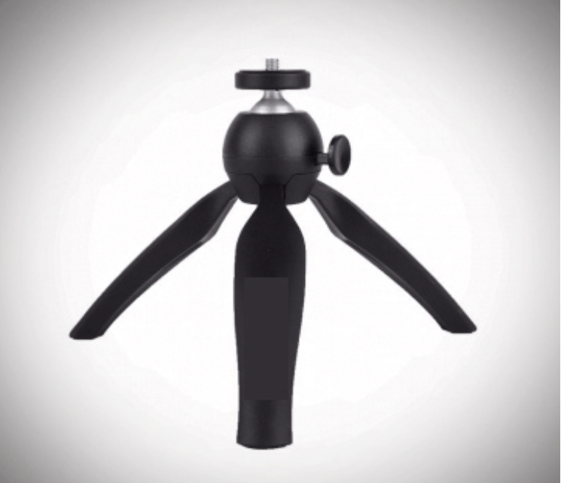
Mini tripod | Laserglow
Laser adaptor for tripod
GlowMount Tripod Adaptor | For Galileo, Aries, Hercules | Laserglow
Note: This laser’s beam is great however it uses a lot of battery power – buy several because as they get cold, they weaken.

Batteries for laser CR123A https://www.amazon.ca/dp/B07TDP9CVS/ref=redir_mobile_desktop?_encoding=UTF8&aaxitk=1014d8f97222fbfe42de63cb8e8a43c5&content-id=amzn1.sym.29a29880-8c3e-4ead-af52-123ee4e84f29%3Aamzn1.sym.29a29880-8c3e-4ead-af52-123ee4e84f29&hsa_cr_id=4709480640501&pd_rd_plhdr=t&pd_rd_r=db2d1603-b8f9-4560-af44-63bfffbac39a&pd_rd_w=gu4sZ&pd_rd_wg=ALvmV&qid=1694442977&ref_=sbx_be_s_sparkle_mcd_asin_0_img&sr=1-1-9e67e56a-6f64-441f-a281-df67fc737124

Recommended: Buy a power bank or two. The iPad for viewing and the iPhone behind laser will use a lot more battery because of their roles.

NOTE: Some of this equipment is not brand specific if you find something similar that works, great!

