

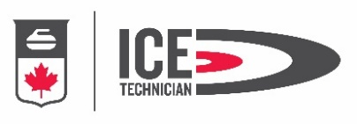

Certified Curling Club Ice Technician Course
October 16-19, 2025

Dates: Oct 16 – Oct 19, 2025

Location: Miramichi Curling Club

Registration & Payment Deadline Date: October 2, 2025

Cost: $275.00 made payable by e-transfer to nbca@nb.sympatico.ca

Minimum course capacity is six (6)
Maximum course capacity is twelve (12)
Placement Confirmed Upon Completion of On-Line Registration AND Receipt of Payment

Course Prerequisites: Course participants required to provide proof of one of the following prior to registration deadline date:

- Trained Assistant Ice Technician
- World Curing Federation-Intro to Curling Ice Maintenance (on-line)
(Introduction to Maintaining Curling Ice (worldcurlingacademy.org)
- 12 Months working at a club under supervision of Certified Ice Tech (letter required)
- Former Curling Canada Level 1 Ice Tech Course

Course Schedule: Thursday, Friday & Saturday 8:00 AM -- 8:00 PM
Sunday: 8:00 AM -- 2:00 PM
-----------------------------------------------------------------------------------------------------
Register at: https://nb.curling.io/en/products

On ice footwear & clothing required
If available, please bring your own pebbling can

Direct Questions to
Chris Tapley
icetec@live.ca

