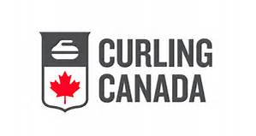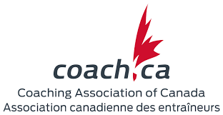

COMPETITION COACH COURSE
Introduction Phase of the Competition Stream
February 20 - 22, 2026

Date: Friday, Feb 20 - Sunday, Feb 22

Location: Curl Moncton

Registration & Payment Deadline: February 6, 2026

Minimum course capacity is 6.
Maximum course capacity is 12.
Placement is guaranteed upon receipt of payment.

Fees: $275 made payable by e-transfer to nbca@nb.sympatico.ca

Agenda: Friday: 6:00pm -- 6:30pm – Registration
6:30pm – 9:00pm – Workshop (MED)
Saturday: 8:30am – 5:00pm – Workshop
Sunday: 8:30am -- 4:00pm -- Workshop

Register at: https://nb.curling.io/en/products

On Ice Footwear & Clothing Required

Questions?
Contact Curling NB Technical Director
Dean Grattan
nbcatechdir@gmail.com

